Mr. D. Denike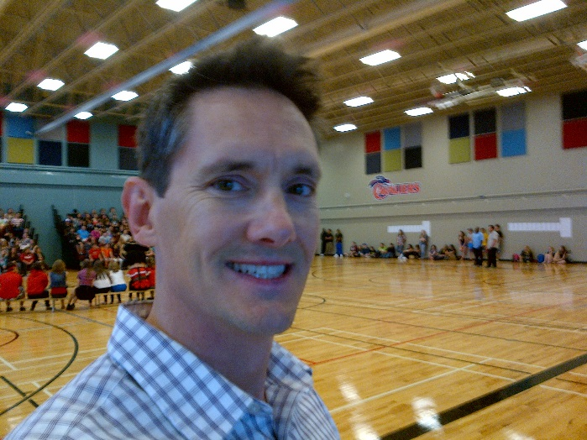

Career Path:

Education
- Saint Mary’s University, Bachelor of Arts
- Université Catholique de l’Ouest, France, Diplôme en Études Supérieure
- Nova Scotia Teachers College, Bachelor of Education
- Dalhousie University, Masters of Teacher French as a Second Language
- Université Sainte-Anne, Masters of Education

Certification
- St-John Ambulance First-Aid/CPR

Employability Skills

Volunteering

